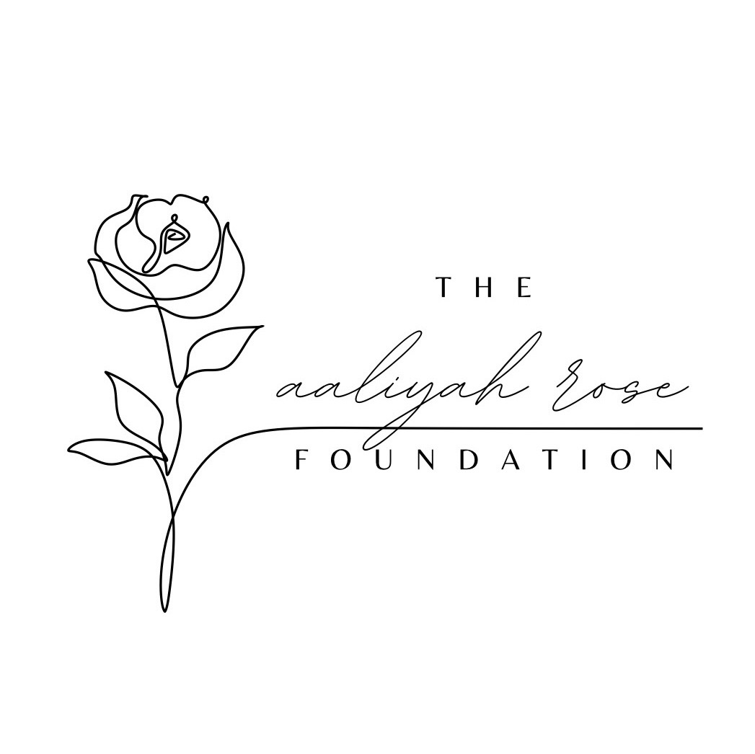
The Aaliyah Rose Scholarship Application Form
——————————————————————————————

About the Aaliyah Rose Scholarship
The Aaliyah Rose Scholarship honors the legacy of Aaliyah Rose, celebrating her unwavering resiliency, deep commitment to community service, and exceptional leadership.
This scholarship recognizes a student who embodies these same core values — someone who has demonstrated strength through adversity, made a meaningful impact through volunteerism, and shown leadership within their community.
The recipient will be a shining example of perseverance, service, and inspiring others through their actions.

Personal Information
Full Name: ___________________________________________
Date of Birth: ________________________________________
Address: ___________________________________________
City, State, ZIP Code: ___________________________________________
Phone Number: ___________________________________________
Email Address: ___________________________________________

Academic Information
Current School: ___________________________________________
Intended College or Trade School: ___________________________________________
Cumulative GPA: ___________________________________________
Intended Major/Area of Study: ___________________________________________

Community Service Information
Briefly list your community service activities and roles (you will expand in your essay):
- _______________________________________________________
- _______________________________________________________
- _______________________________________________________

Essay Section
Please attach a typed essay answering the following prompts:
- What are your plans post-graduation?
- How will this scholarship impact you?
- What does resiliency mean to you?
- Provide an example of how you have overcome obstacles in your life and achieved resiliency.
(Recommended Word Count: 500–750 words)

Supporting Documents
Please ensure the following items are included with your application:
[ ] Academic Transcript
[ ] College/Trade School Acceptance Letter
[ ] Two Letters of Recommendation
[ ] Completed Application Form and Essay

Applicant Certification
I certify that the information provided is true and complete to the best of my knowledge.
Signature: ___________________________________
Date: ________________________________________

Applications can be emailed to kyrie@aaliyahrosefoundation.org, submitted via our website aaliyahrosefoundation.org, or mail to 21751 N 575th St., Hume, IL 61932 no later than March 1, 2026.

